

OEM 13c and Service Now integration
Oracle Enterprise Manager 13c

Project



DISCLAIMER

This document is strictly private, confidential and personal to its recipients and should not be copied, distributed or reproduced in whole or in part, nor passed to any third party.

Version history
Date | Version | Description | Author
2020-11-12 | 1.0 | Initial Version | Sharang Dhar Dwivedi

Contents
Version history 3
1. Introduction 4
2. Features: 5
3. Configuring the ServiceNow Ticketing Connector 5
3.1. Connection Settings 6
3.2. Template Settings 6
4. ServiceNow details 7
5. Service request Details in ServiceNow 11
6. Flow Diagram 12

Introduction

Oracle Enterprise Manager provides feature to integrate OEM with ServiceNow to manage and monitor the OEM incidents/alerts within ServiceNow. Using HTTPS web service integration feature we can create, update, resolve, close, or reopen tickets on the ServiceNow system for any incident/alert generated in Enterprise Manager.

Features:

- Crate SR in Service Now corresponding to the Oracle Enterprise Manager generated incidents.
- Auto resolve SR in ServiceNow if incident has been cleared in OEM.
- Grace period setting to avoid multiple tickets in Service Now for same the incident.
- Reopen the same ticket if incident occurs within specified grace period.

Configuring the ServiceNow Ticketing Connector

Setup -> Extensibility -> Management Connectors -> General (tab)
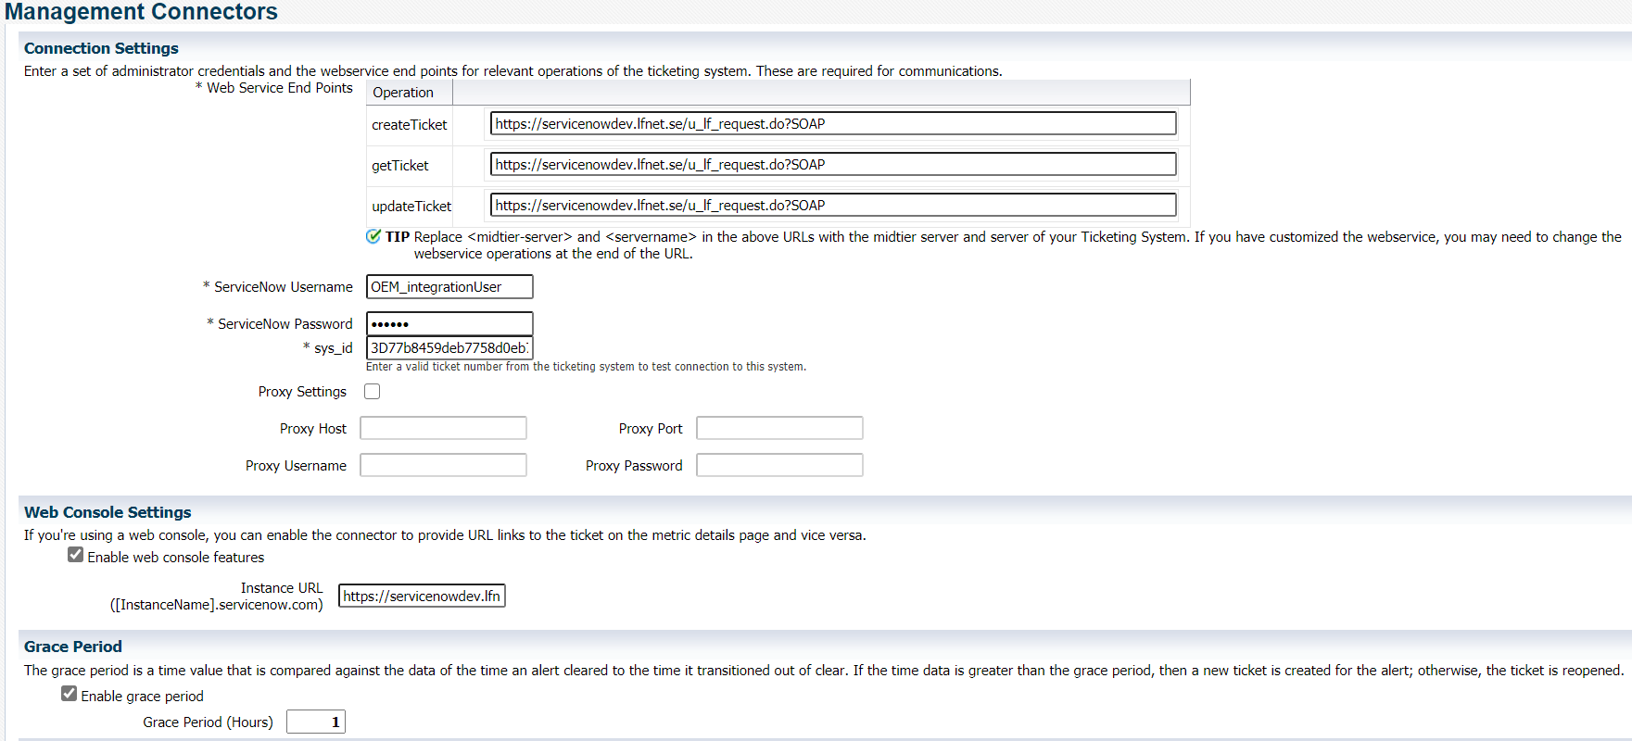

In this connection setting page provide the ServiceNow web service URL, ServiceNow user credential, sys_id value and set the grace period as per requirement.

3.1. Connection Settings

Web Service End Points – URL of the web service endpoint to call for the createTicket, updateTicket, and getTicket operations.
https://servicenowdev.lfnet.se/incident.do?SOAP
ServiceNow Username - ServiceNow user (OEM_integrationUser) with appropriate privileges/roles in ServiceNow to create, update, and query tickets in ServiceNow. All tickets created through the connector are generated with this user account.
Required permissions:
- itil
- soap_create
- soap_update
- soap_query
ServiceNow Password – Password can set/reset by ServiceNow team.
sys_id -sys_id number is required to test the connection when you save the configuration. A valid sys_id can be obtained by opening any service request URL
https://servicenowdev.lfnet.se/nav_to.do?uri=%2Fu_lf_request.do%3Fsys_id%3Dd1158577d79ce490317f68fa65cdf769%26sysparm_stack%3D%26sysparm_view%3D

Grace Period: The grace period interval accepts the number of hours as any integer value. For example, 1 or 2.

3.2. Template Settings

Setup -> Extensibility -> Management Connectors -> General (Template)
At the time of ServiceNow connector instance creation below ServiceNow templates will be created.
- Create Ticket Response
- Get Ticket
- ServiceNow Create and Update
- ServiceNow Create, Update, and Close
- ServiceNow Create, Update, and Resolve
- Get Ticket
We must modify these templates as per our requirement.
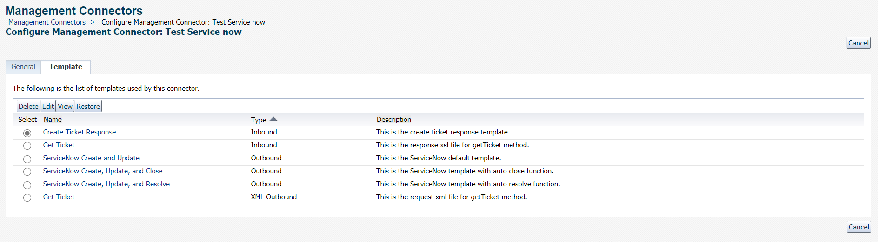

ServiceNow details

ServiceNow WSDL feature will be used to handle the ServiceNow SOAP requests from OEM connector. To handle the tickets in ServiceNow, user (OEM_integrationUser) should have appropriate privilege to create, update and resolve the tickets. As per Oracle documentation below privileges should be provided to ServiceNow user:
- itil
- soap_create
- soap_update
- soap_query
GET method will be used to complete initial handshak between OEM and ServiceNow using sample sys_id provided in the connection page.
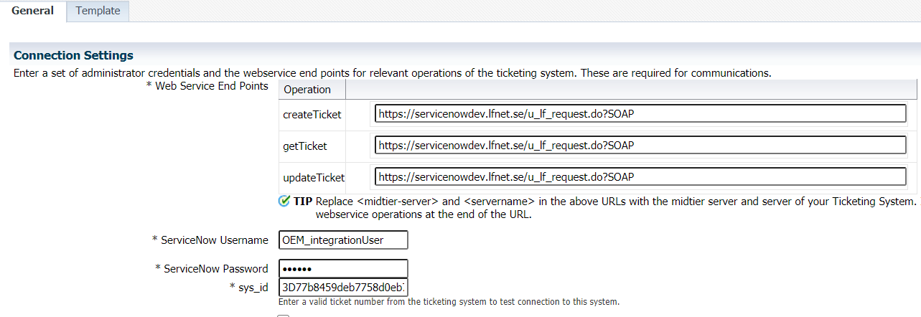

Get Ticket Request OEM Template will use to query the ServiceNow using provided sys_id value. get Ticket Response OEM Template will update the status in the OEM. Both template details can be found in the above section.
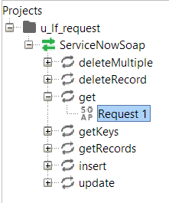

INSERT method to create new tickets in the service now.
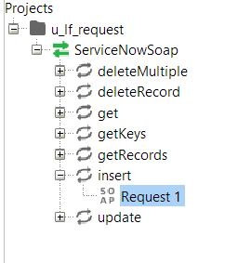
<short_description> OEM incident summary </short_description>
<description>OEM incident summary</description>
<assignment_group>EttSAK Test Infrastructure</assignment_group>
<u_type>non-standard_request</u_type>
<category>Applications</category>
<u_task_for>OEM integration (OEM_integrationUser) </u_task_for>
<u:comments> OEM incident details </u:comments>

UPDATE method to resolve the tickets and reopen the SRs if same incident occurred again in OEM within grace period. OEM will use the sys_id value of ServiceNow SR to track the status, resolve and reopen the tickets.
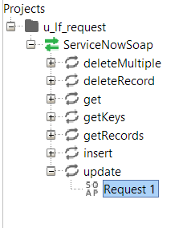
To resolve the SRs in ServiceNow, OEM connector will call the UPDATE method by suppling below mentioned values
<short_description> OEM incident summary </short_description>
<description>OEM incident summary</description>
<state>26</state>
<close_code>Sucessful</close_code>
<close_notes>Enterprise Manager Resolution</close_notes>
<closed_at>LastUpdatedDate timestamp </closed_at>
<u:comments> OEM incident details </u:comments>

In order to Reopen the ticket in ServiceNow OEM template will call the UPDATE method by providing below parameters
<short_description> Updated OEM incident summary </short_description>
<description> Updated OEM incident summary</description>
<u:comments> OEM incident details(Reopened) </u:comments>

Service request Details in ServiceNow

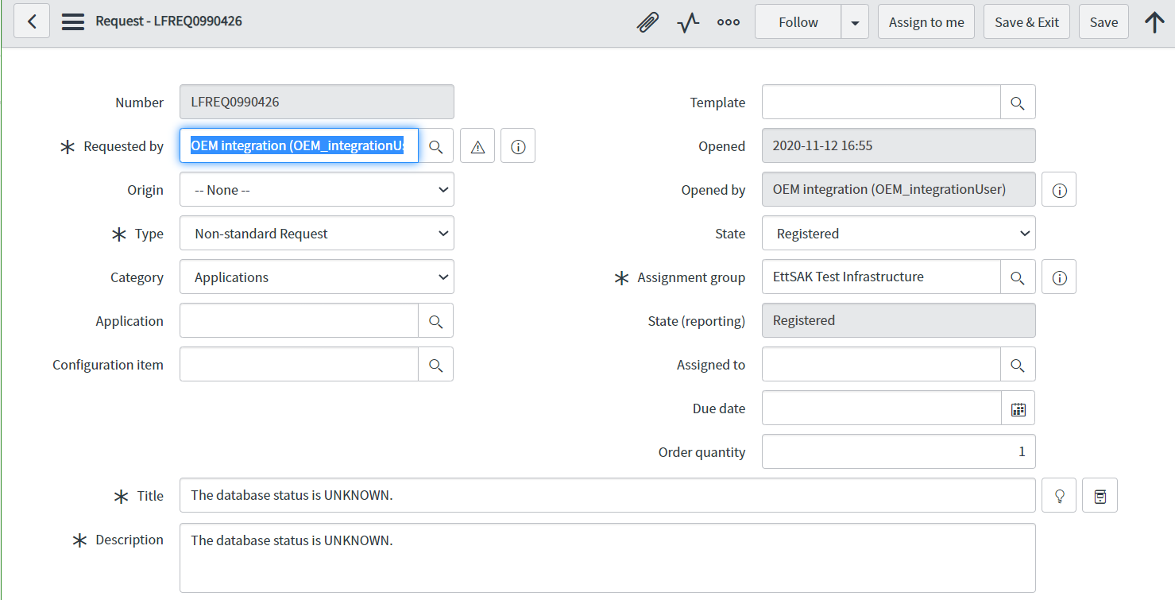

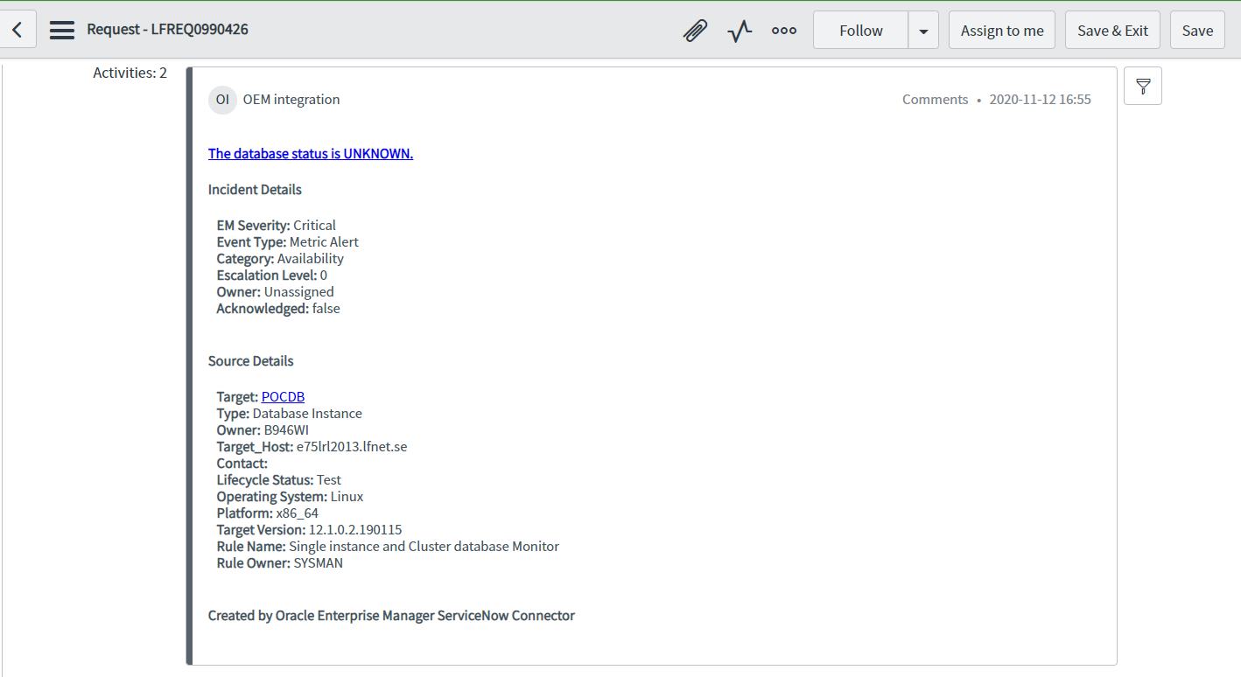

Flow Diagram

Flow diagram to explain how created SR in ServiceNow will be handled.

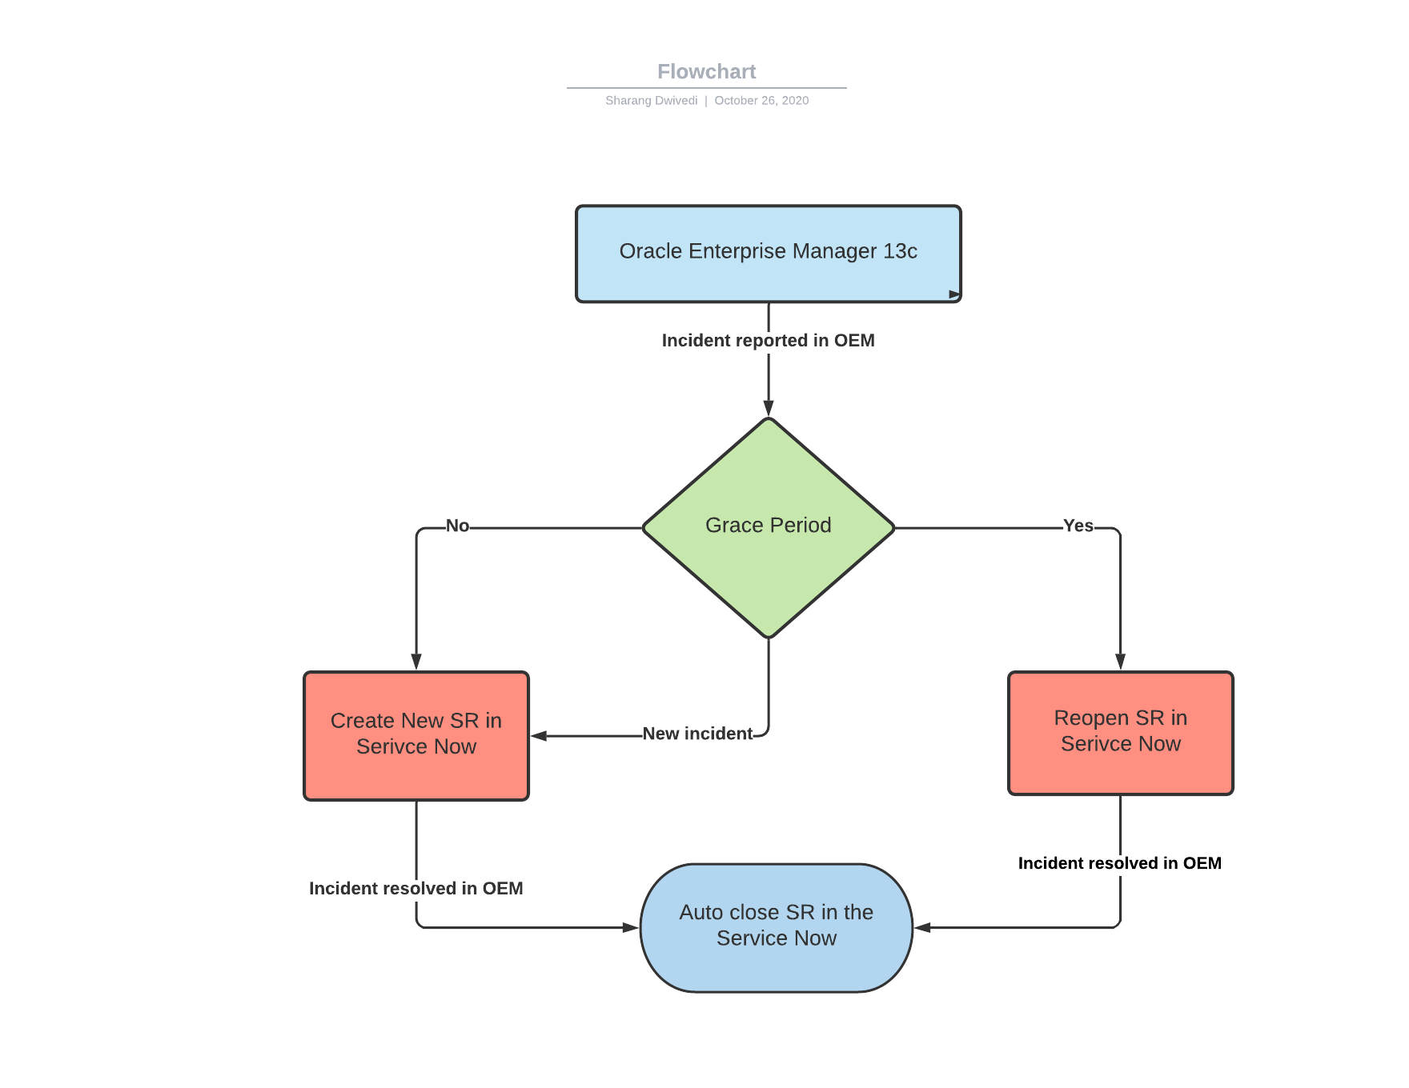

END OF DOCUMENT

